EM425 Assignment #2

*Problem Statements*

1. (Based on problem 3.5) Determine the fourth root of 200 by finding the numerical solution of the equation 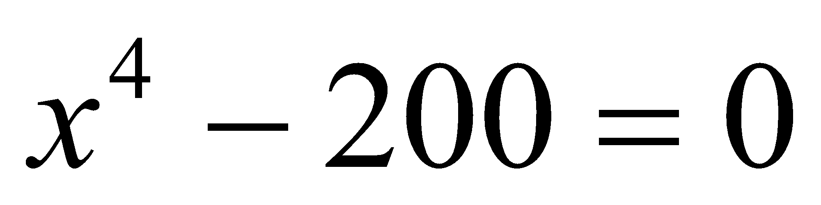. Use Newton’s method (by hand). Start at x = 8 and carry out the first five iterations.

2. (Based on problem 3.22) Create a function to carry out Newton’s method for finding a root for a nonlinear equation. The function should have the signature: Xs = NewtonSol(Fun, FunDer, Xest) where, Xs is a root, Fun and FunDer are handles to the function to be solved and its derivative, and Xest is an initial starting guess for the root. Your function should use the estimated relative error as a stopping criteria with a threshold value of 10-9. The number of iterations should be limited to 100; if the solution is not found in 100 iterations the program should stop and display an error message. Use your function to solve the equation given in problem #1.

3. (Based on problem 3.24) Steffensen’s method is a scheme for finding a numerical solution of an equation of the form 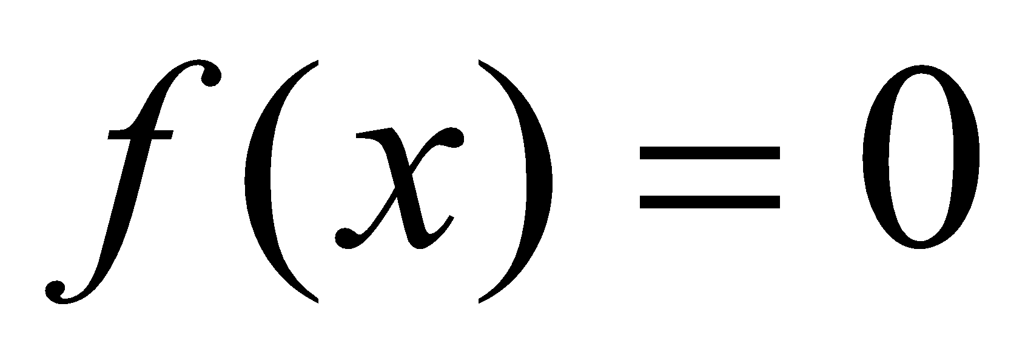 that is like Newton’s method but does not require the derivative of 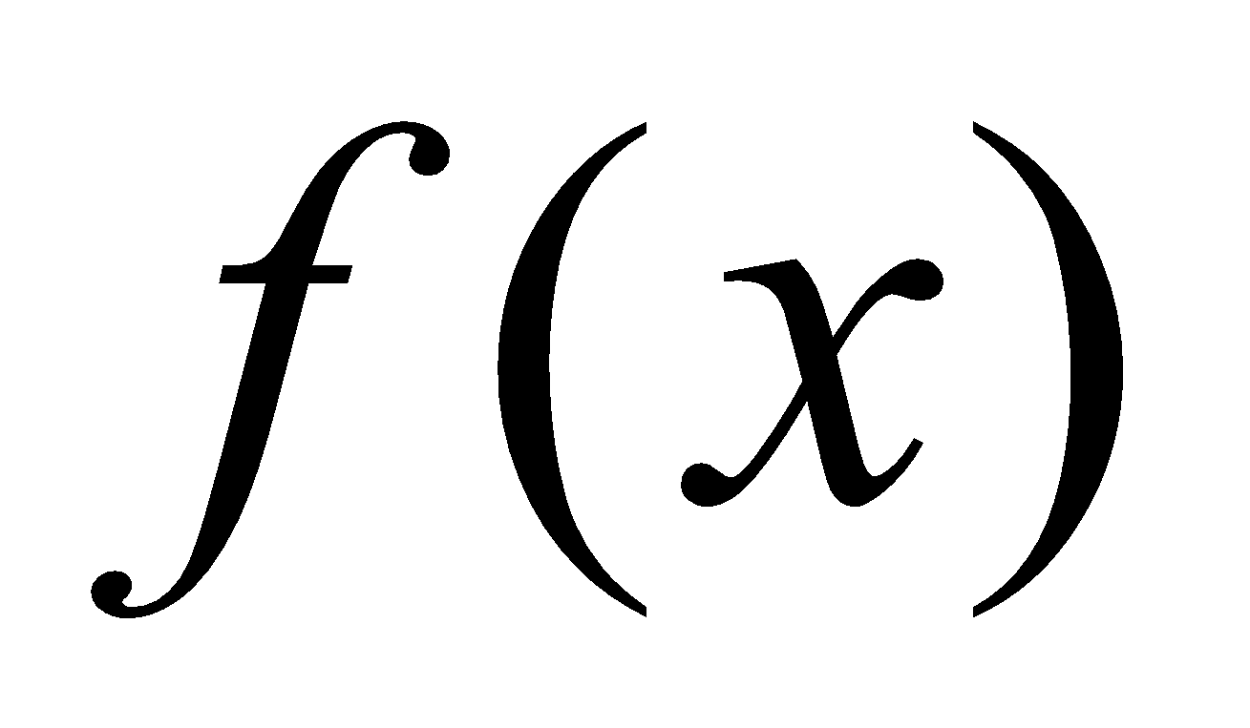. The solution process starts by choosing a point 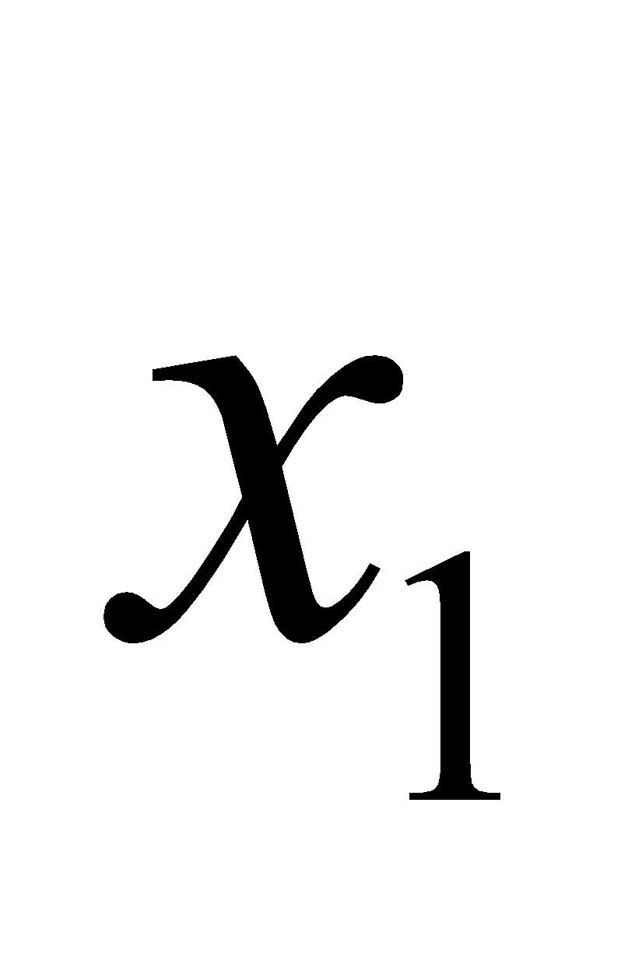, near the solution, as the first estimate of the solution. The subsequent estimates of the solution 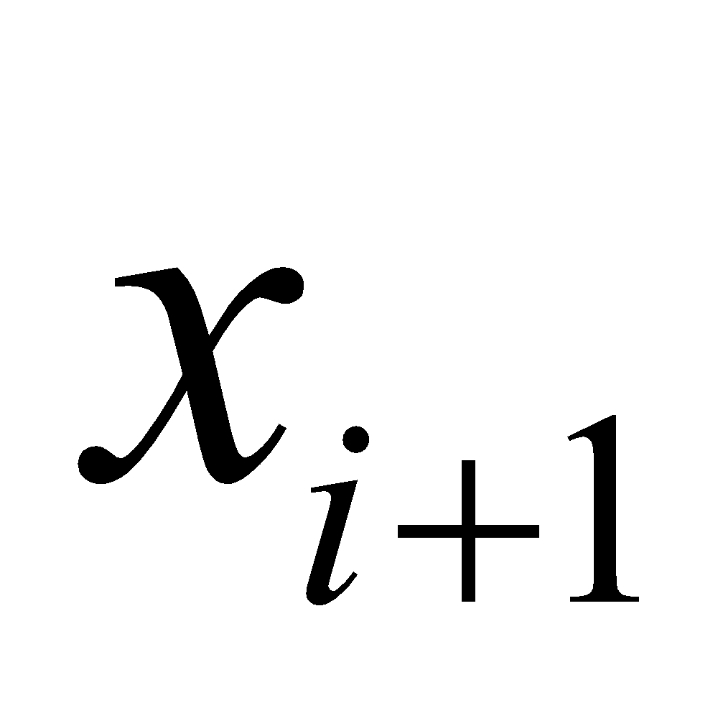 are calculated by:

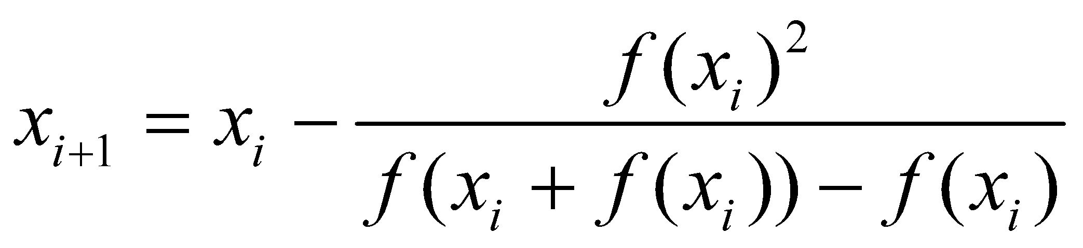

Write a MATLAB function that solves a nonlinear equation with Steffensen’s method. The function signature should be: Xs = SteffensenRoot(Fun,Xest) where Xs is a root, Fun is a handle to the function you wish to solve, and Xest is the estimated root. Use your function to find the root of 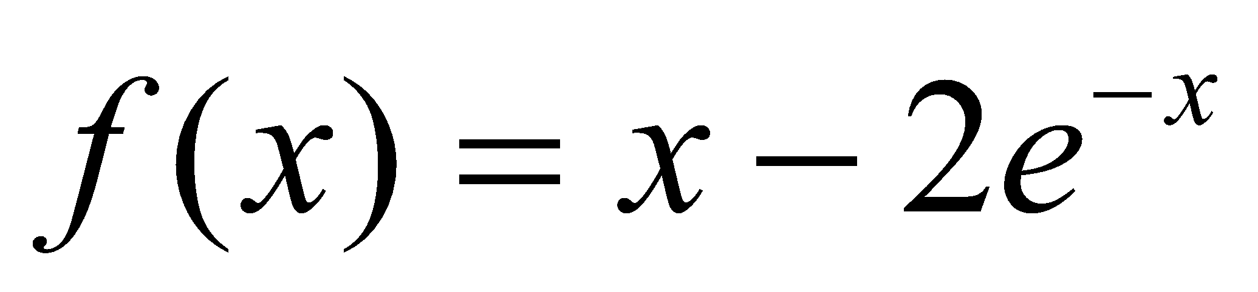. Use 2 as an initial starting point. As termination criteria, use the estimated relative error with 1x10-9 as a tolerance, and maximum iterations with a limit of 100.

4. (Based on problem 3.32) A simply supported I-beam is loaded with a distributed load, as shown in the figure. The deflection, 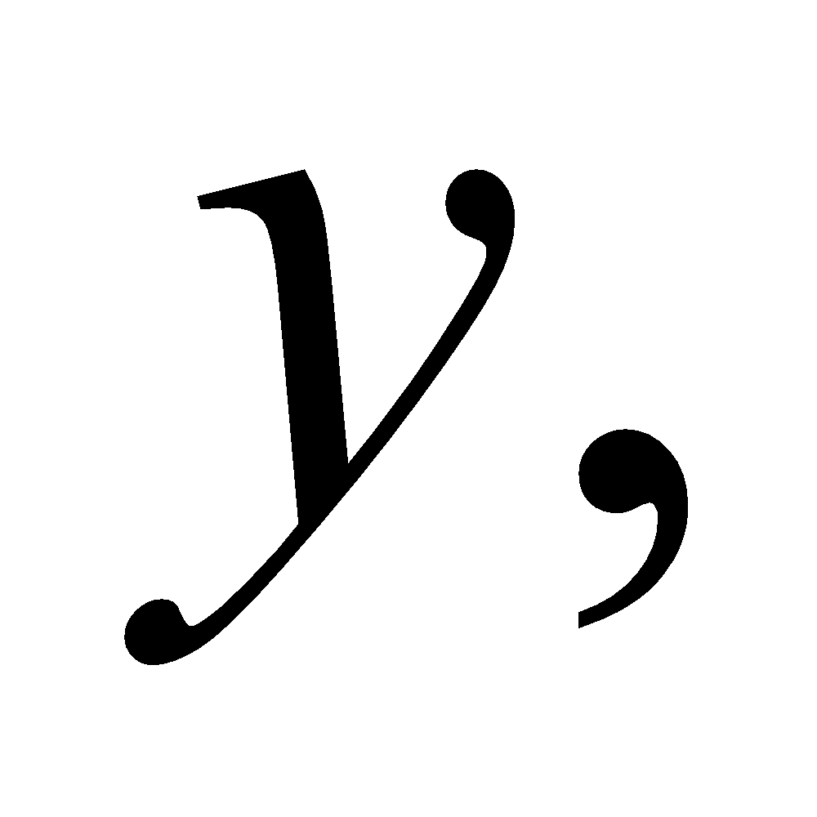 of the centerline of the beam as a function of the position, 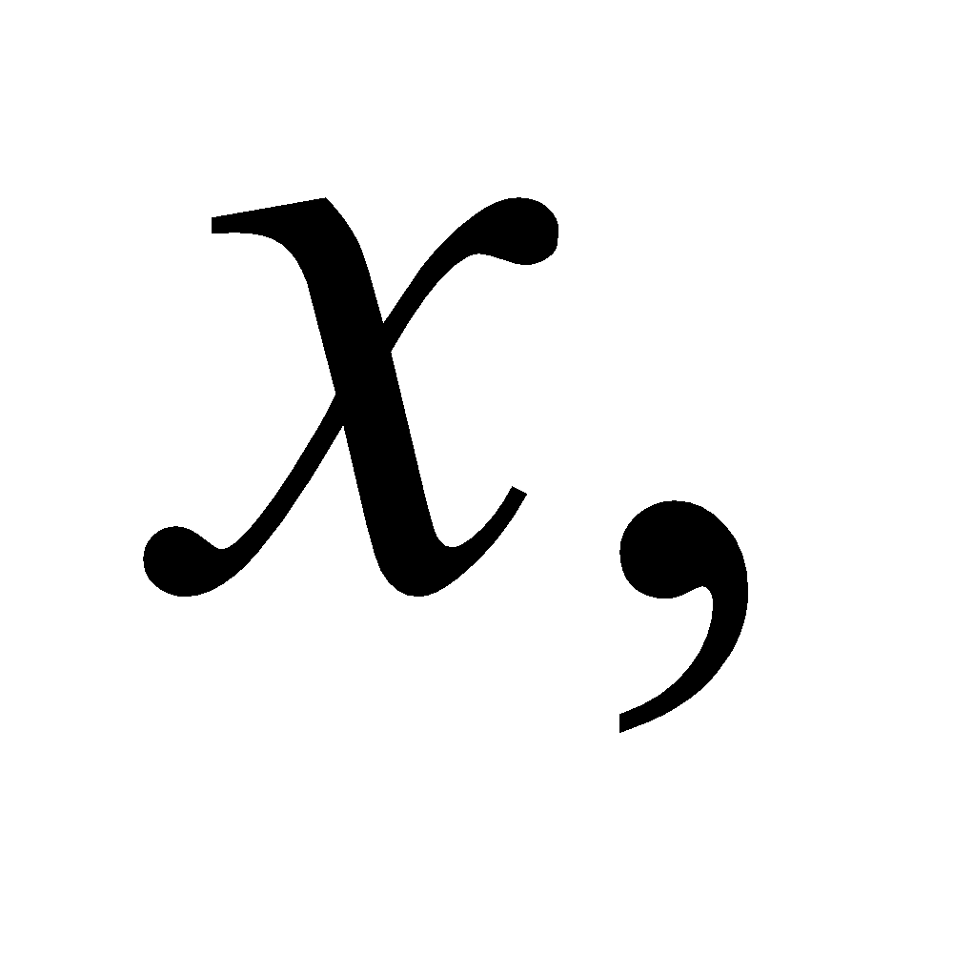 is given by the equation: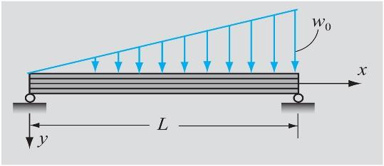

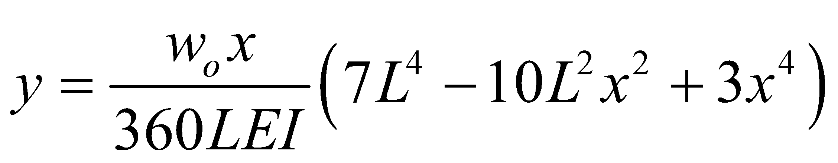

Where  = 4m is the length,  = 70 GPa is the elastic modulus,  = 52.9x10-6m4 is the moment of intertia, and  = 20 kN/m is the distributed load.

Find the position  where the deflection of the beam is maximum, and determine the deflection at this point. (The maximum deflection is at the point where 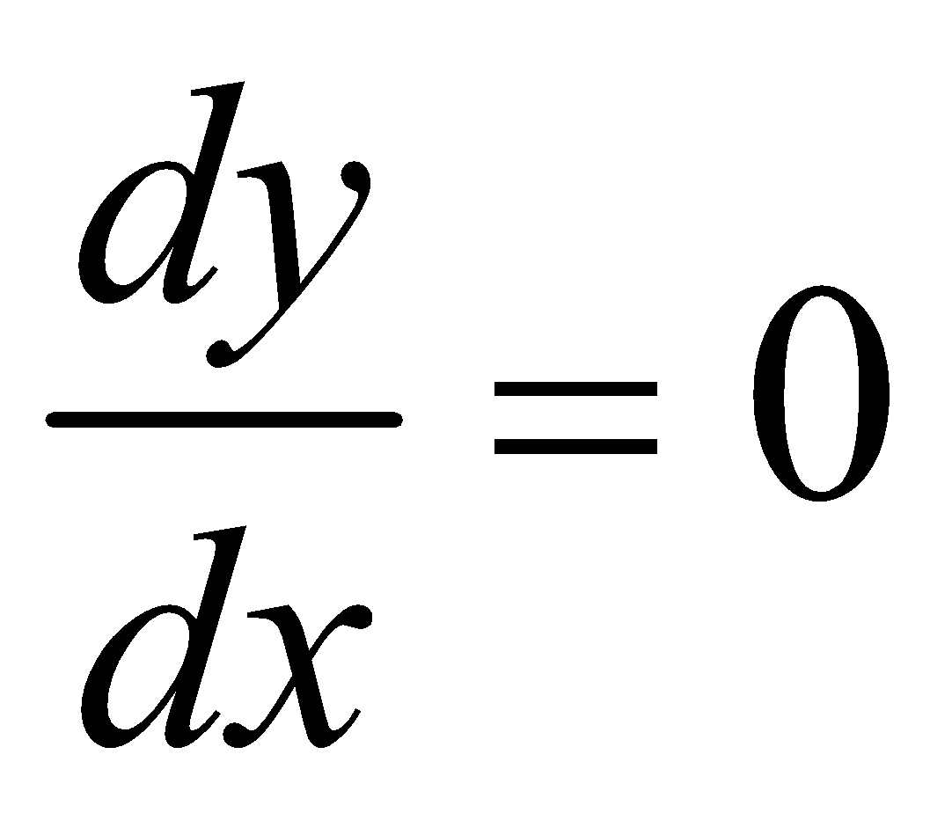. )

1. Write a MATLAB function that solves this nonlinear equation using the Secant method. The function signature should be Xs = SecantRoot(Fun,Xa,Xb,Err,imax) where Err is the estimated relative error which you should set at 1x10-9. Use 1.5 for Xa and 2.5 for Xb.
2. Repeat the solution of this equation with NewtonSol and SteffensonRoot.

**Numeric Solutions**

**Problem #1:**

If x1 = 8, x6 is approximately 3.7902

**Problem #2:**



**Problem #3:**



**Problem #4:**

The solution for all three methods should be similar. For my implementations:

